**DIGITAL SYSTEMS DESIGN**

**PROJECT**

**BURGLER ALARM**



**VAISHNAVI KUNDESHWARA BHAT – 4NM20IS170**

**VAISHNAVI S RAI – 4NM20IS171**

**VAISHNAVI SHETTY – 4NM20IS172**

* **INDEX**

|  |  |
| --- | --- |
| **SYNOPSIS** | **PAGE 3** |
| **COMPONENTS USED** | **PAGE 3** |
| **CIRCUIT DIAGRAM** | **PAGE 3-4** |
| **WORKING** | **PAGE 4** |
| **CONCLUSION** | **PAGE 4** |

* **SYNOPSIS**

**The project is a burglar alarm. When the burglar alarm is switched on, if anybody passes through it, the buzzer beeps.**

* **COMPONENTS** **USED**

**1) Led Bulb**

**2) Sensor**

**3) Buzzer**

**4) 9V battery**

**5) IC LM324**

**6) 4 resistors**

**7) Transistor**

**8) Breadboard**

**9) Wires**

* **CIRCUIT DIAGRAM**

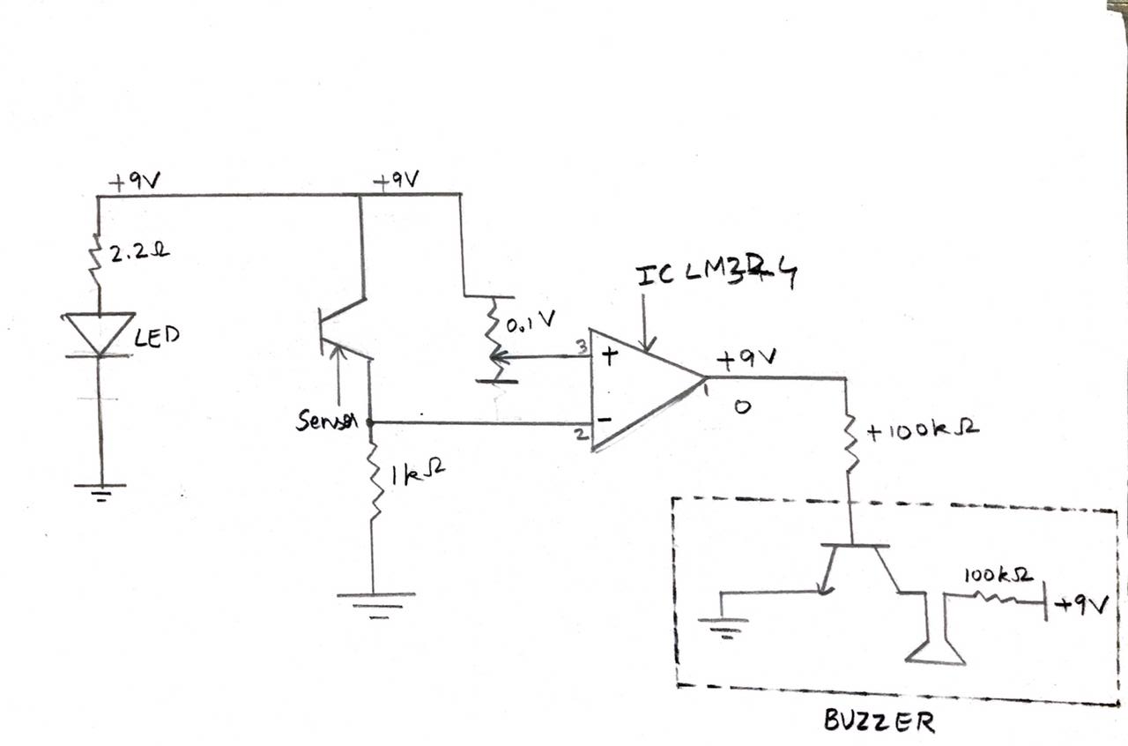

**The LED light is connected to ground and another connected has been made to +Vcc through a resistor to avoid high voltage. The sensor has 3 connections out of which the middle one is considered to be a dummy. One of the wires is connected to the input of IC that pin 2. From the same wire another connection has been made to the ground through a resistor. From the other wire of the sensor, a connection has been made to +Vcc. The inputs of the variable resistor have been given from +Vcc and ground. Its output is given to IC input that is PIN number 3. The output of the IC is taken through a resistor and given to the base of the transistor collector. Another connection has been made at the base to ground and another one has been taken by another resistor which is in turn connected to the buzzer. The buzzer’s another connection is given to +Vcc. Few more connections to ground have been made.**

* **WORKING**

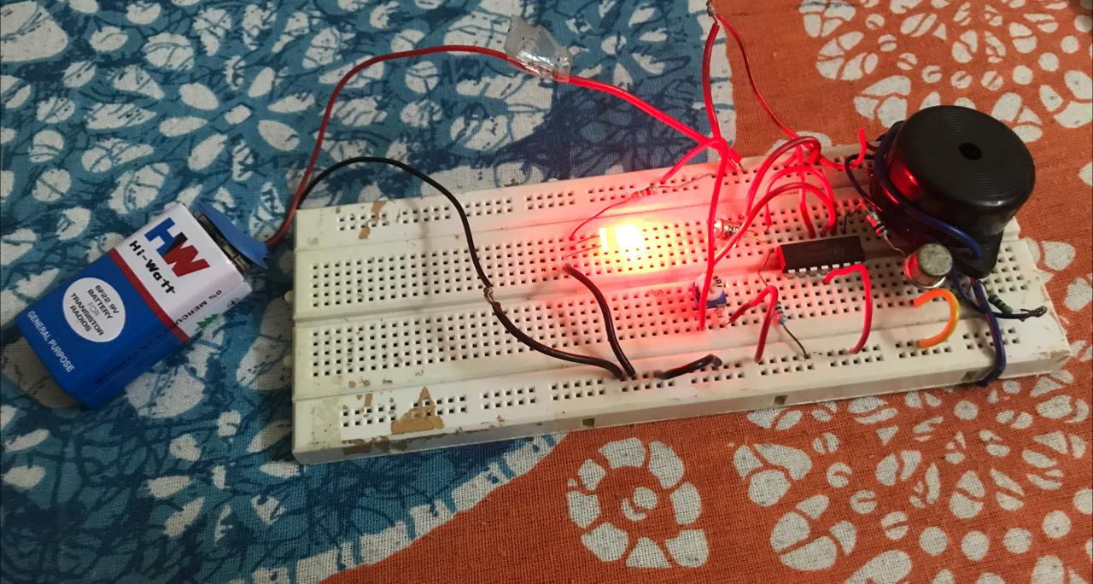

**The working of this simple circuit depends mainly on the output of IC. Here the sensor and the led bulb are considered to be as a door. When the light is continuously falling on the sensor negative part of the IC dominates due to which 0 voltage is sent to the buzzer and it doesn’t beep. It means that no one has passed through. When u place your finger in between the sensor and led bulb the light is blocked due to which no light falls on the sensor. The circuit is anyways activated but the positive part of the IC is activated that is through the variable resistor. The voltage that is 9V from the battery is sent to the buzzer and it beeps, indicating that someone has passed through.**

**This is the working of a simple burglar alarm.**

* **CONCLUSION**

**This is a common circuit used in many commercial stores and even homes. It is used to protect places from theft or to warn the people of unwanted visitors. It is easy to make and efficient to quite an extent. Most importantly it is cost efficient.**

**THANK YOU**